**SSH connection with ADLS Gen-2 Container. Users should have access to specific containers only they should not access other containers.**

Steps:

1)Create an ADLS Gen-2 storage account

Begin by creating an Azure Data Lake Storage Gen-2 storage account through the Azure portal.

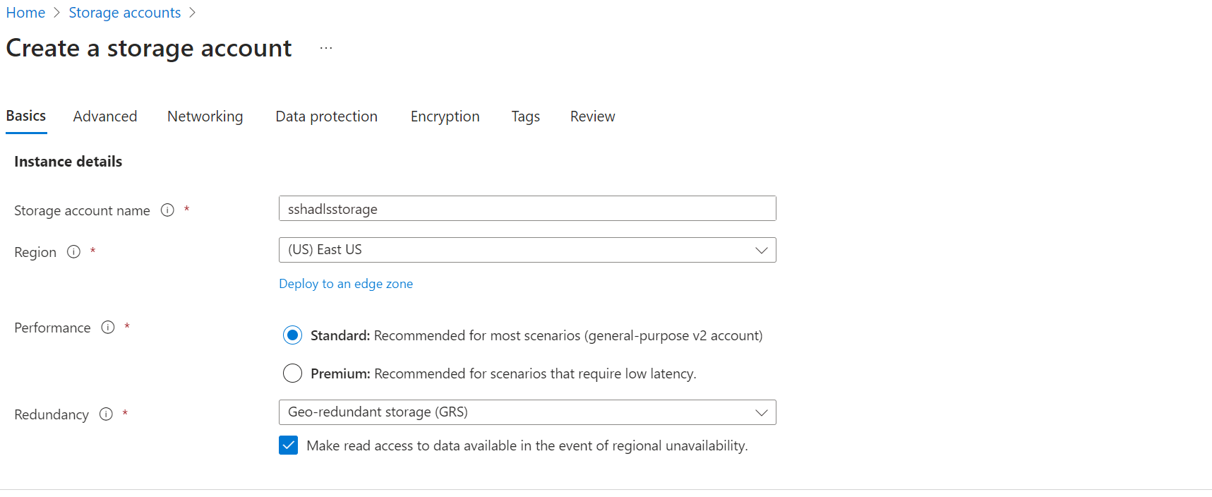

2)Enabled below fields

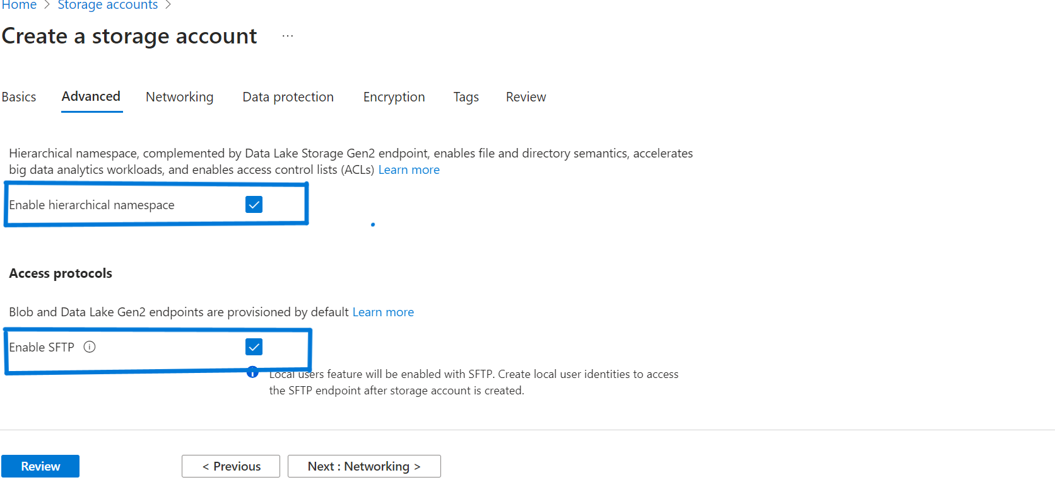

3)Click on Create

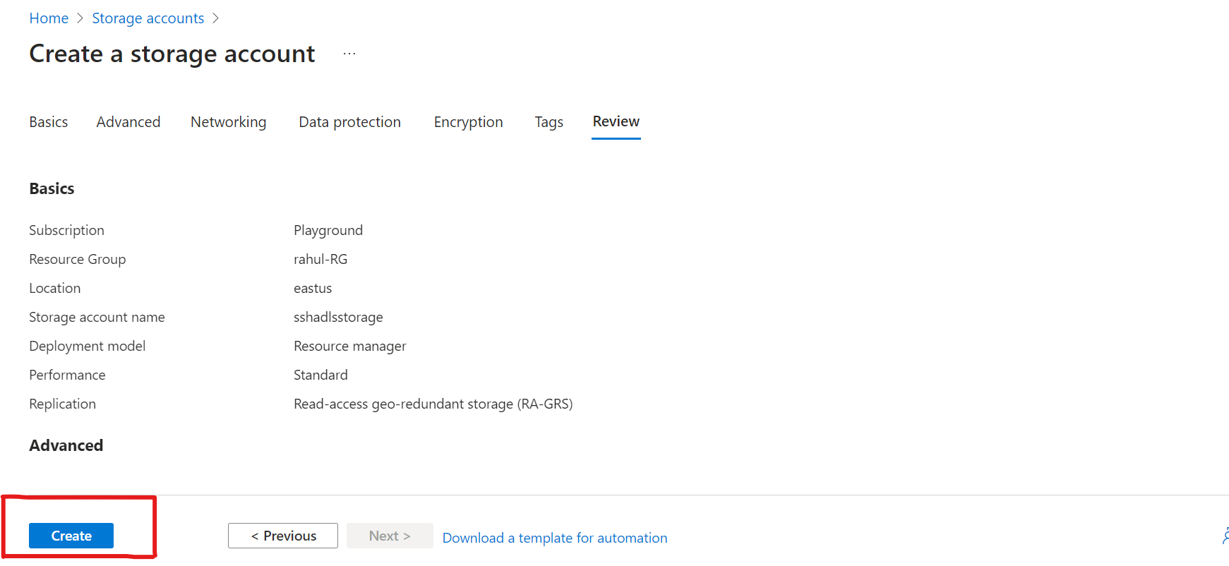

4)Create a container inside your storage account

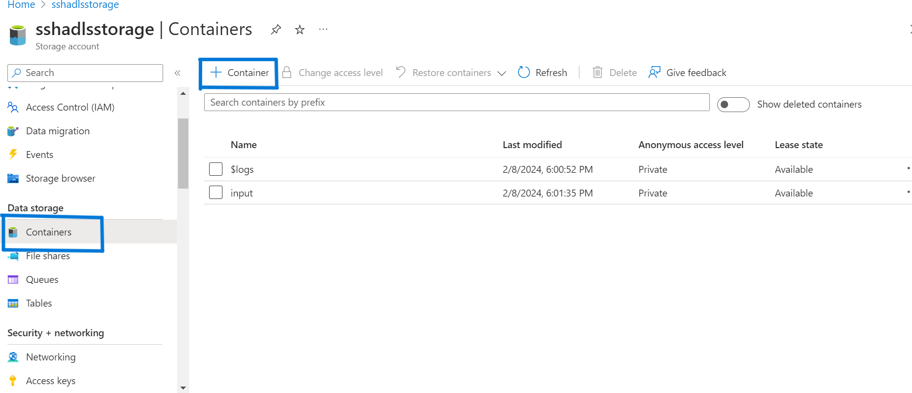

5)In the SFTP provide the following fields:

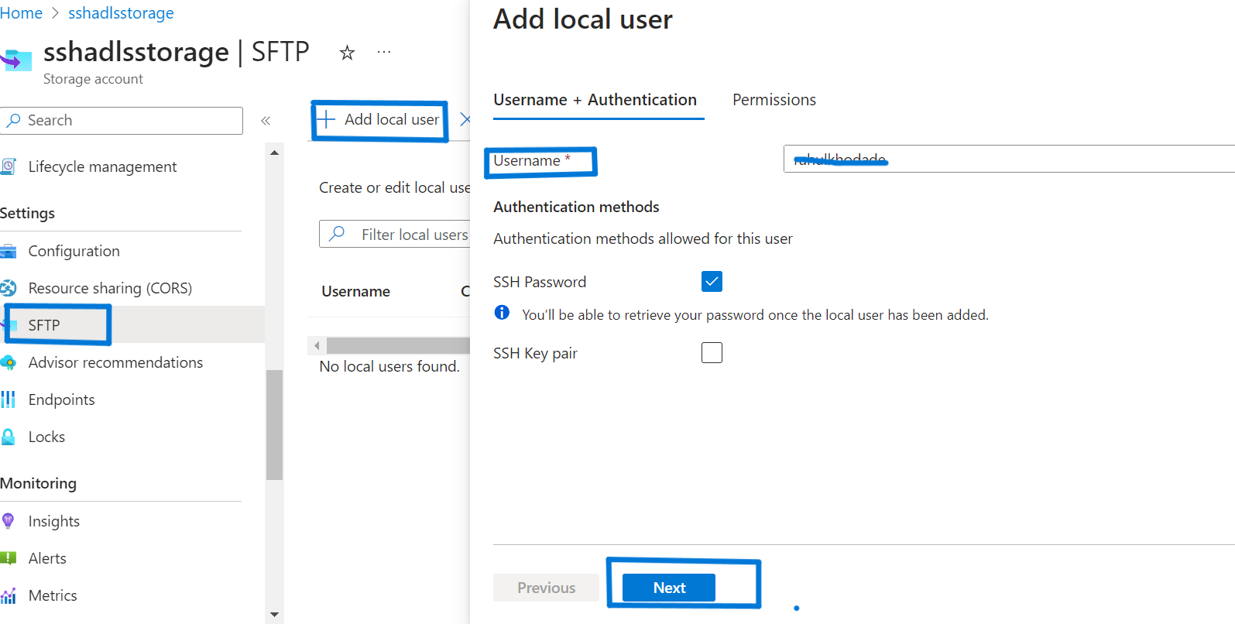

6)

In the below fields select your containers, provide the appropriate permission.

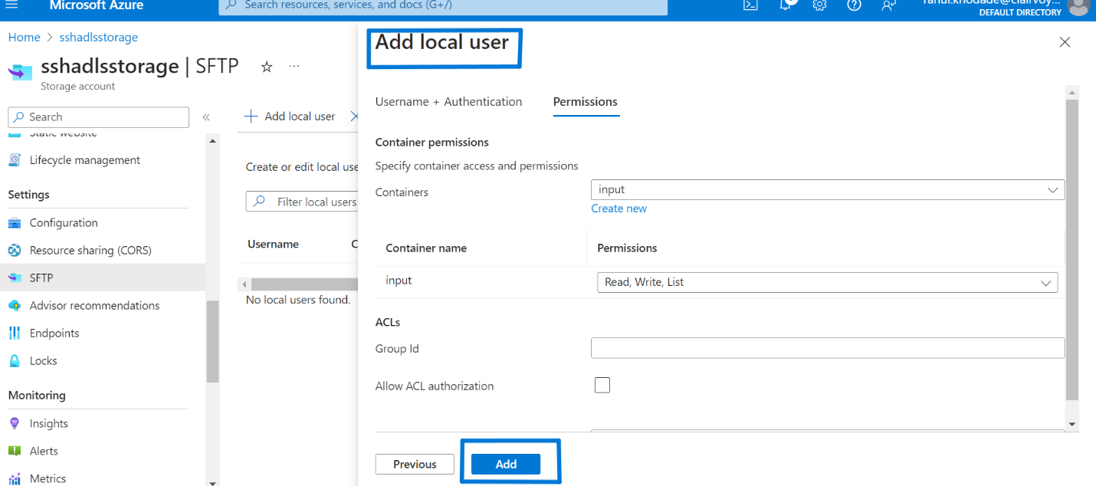

7) Copy your SSH password and connection string and save it for further used.

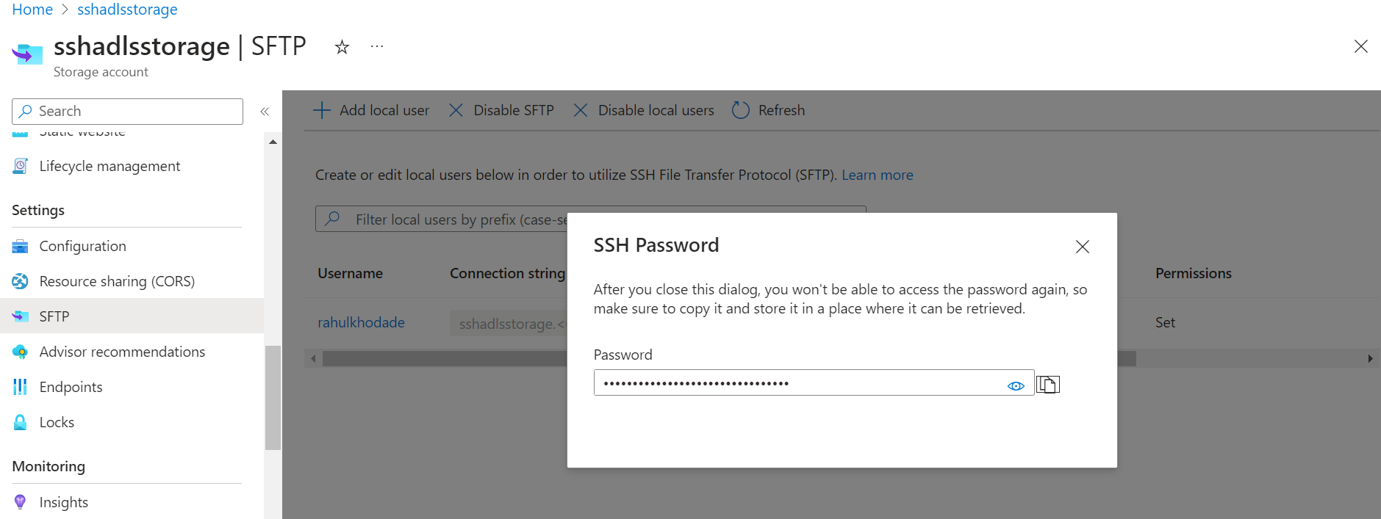

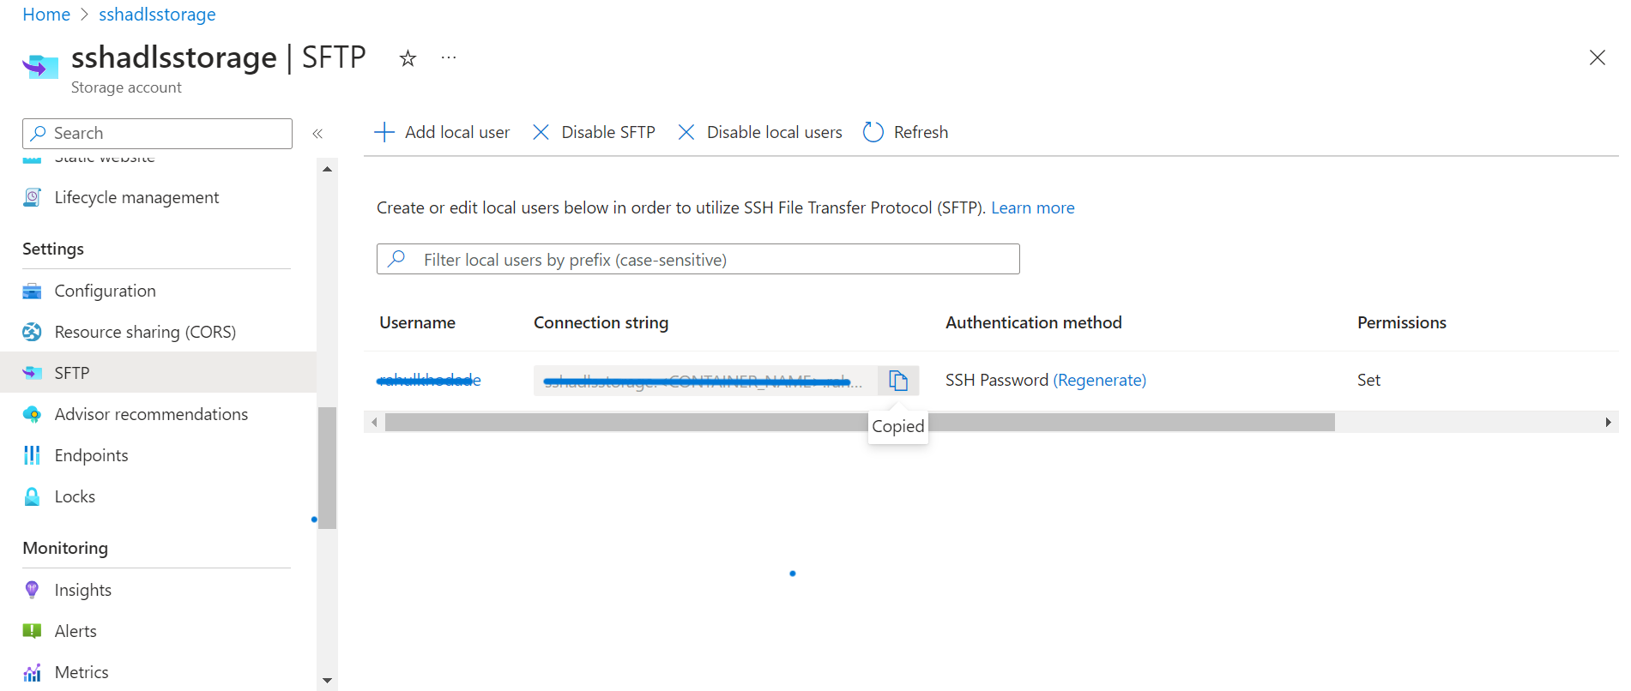

8)Open cmd and run following command:

i) sftp sshadlsstorage.<CONTAINER_NAME>.rahulkhodade@sshadlsstorage.blob.core.windows.net (your copied connection string)

ii)Enter your copied password

iii) put "C:\\Users\\Rahul179384\\Desktop\\data\\rahul.txt(**Your local file path**)" "/container folder name" (Put the local file into the container)

iv) get data "C:\\Users\\Rahul179384\\Desktop\\data\\" (get the file)

Once the 3rd step run then file will generate in ADLS conatiner

